ASSIGNMENT-2

A)HANDILING THE MISSING VALUES

1) handling using mean

We cant handle missing values by mean because the tabular data consists of combination of int and str values.

2) **handling missing values through median and mode**

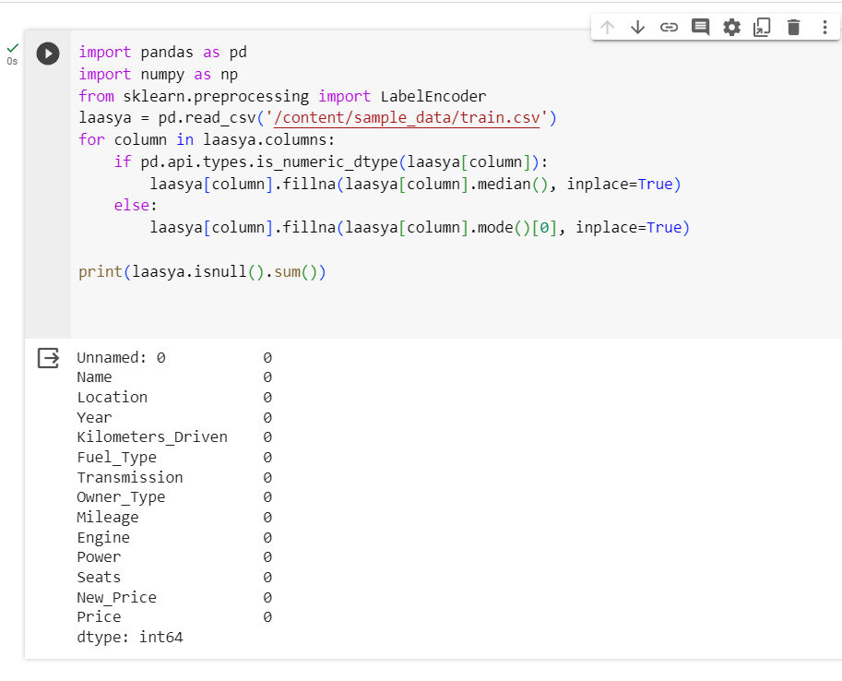

3.) **handling missing values using drop but we don’t use them because we loss the drop data**

QUESTION-2

Remove the units from some of the attributes and only keep the numerical values

QUESTION -3

Change the categorical variables (“Fuel_Type” and “Transmission”) into numerical one hot encoded value

QUESTION-4

Create one more feature and add this column to the dataset (you can use mutate function in

R for this). For example, you can calculate the current age of the car by subtracting “Year” value

from the current year

